RESUME

DHAREDDY ROHITH REDDY

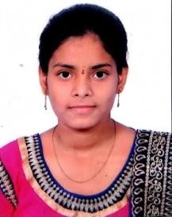 Email id: [rohithreddy5048@gmail.com](mailto:rohithreddy5048@gmail.com)

Mobile: 6300493135

# Objective:

* To enhance my professional skills, capabilities and knowledge in an organization which recognizes the value of hard work and trusts me with responsibilities and challenges.

# Education:

|  |  |  |  |
| --- | --- | --- | --- |
| **C**ourse | Institution | Year of passing | Percentage/cgpa |
| B. Tech(CSO)  ( pursing) | Ace engineering  college | 2025 | 8.3 gpa |
| Board of intermediate | Narayana junior  college | 2021 | 92% |
| Secondary School  (SSC) | Narayana High  School | 2019 | 9.5 gpa |

**Skills:**

* Personal skills : Adaptability, Hard Working.
* Programming skills : Java, C, Python.
* Operating Systems : Windows, linux.
* Database : Mysql.

# Projects:

* Developed projects on arduinaUi and raspberry pi

# Certifications:

* I have completed a **Salesforce** certification and got certified

# Extra-circular &Co-circular Activities:

* Participated in Robotics workshop organised by Soham

**Personal Details:**

Name : Dhareddy Rohith Reddy

D.O.B : 27/04/2004

Father’name : D Krishna Reddy Gender : Male Language known : English, Telugu

Address : 1-75/5/2 ,Srinivas Nagar Boduppal

Medchal dist ,pincode:500092

# Declaration:

* I hereby declare that the information mentioned above are correct to best of my knowledge and belief

D. Rohith Reddy